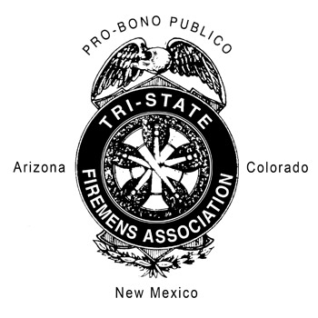
TRI-STATE FIREMEN’S CONVENTION
2023

Memorial Services

BELOW PLEASE LIST NAMES OF FALLEN FIREFIGHTERS FOR THE MEMORIAL SERVICES. NAMES, DEPARTMENT, DATE OF DEATH AND DATE SERVED IN YOUR DEPARTMENT AND IF THE FIREFIGHTER WAS A LIFE MEMBER OF TRI-STATE WOULD BE APPRECIATED AND THIS INFORMATION WILL MAKE THE SERVICE MORE PERSONAL. PLEASE PRINT OR TYPE, AND RETURN FORM WITH YOUR REGISTRATION FORM.

DEPARTMENT’S NAME:

NAME | DATE OF DEATH | YEAR’S SERVED | LIFE MEMBER (YES / NO)

