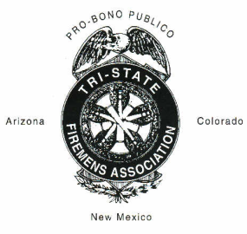
Annual Tri-State Firemen’s Training and Convention
Host:

Convention Event Summary

Event Name | Event Winners | Time
Comedy Skit
Sweepstakes Winner
S. E. Dan Brentari Award
Water Fight

Dear Host:
This form will need to be included in your permanent records packet that you send to TSFA Secretary/Treasurer. This will accumulate your winners in all events and special traveling trophies. Please make sure you complete this form and include it with your contest results.

