TRI-STATE FIREMEN'S
ASSOCIATION
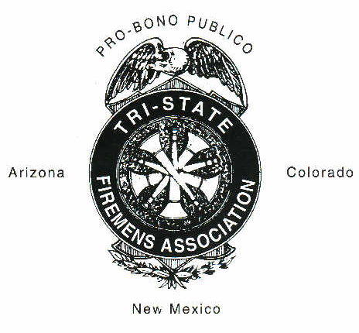

AUGUST 2022
TABLE OF CONTENTS

Page No.

ARTICLE I 1
Organization

ARTICLE II 1
Membership

ARTICLE III 3
Host to Convention, Election of Officers and Board of Directors

ARTICLE IV 4
Duties of Officers Who Host Convention

ARTICLE V 5
Duties of the Board of Directors

ARTICLE VI 6
Meetings

ARTICLE VII 7
Financial Obligation of Convention

ARTICLE VIII 7
Suspension

ARTICLE IX 7
Fiscal Year

ARTICLE X 8
Contest, Rules & Awards

TABLE OF CONTENTS
(Continued)

Page No.

ARTICLE XI 12
Amendments

ARTICLE XII 12
Order of Business

Attachment to Article X, SECTION 8 13

Diagram for TSFA Six Man Hose Lay - left 15

Diagram for TSFA Six Man Hose Lay - right 16

TRI-STATE FIREMEN’S ASSOCIATION BOUNDARY Map 17

Tri-State Firemen's Association cURRENT mEMBERSHIP. 18

Tri-State Firemen's Association ARREAR MEMBERS. 19

Tri-State Firemen's Association Board of Directors. 20

Tri-State Board Signature Page 21

ARTICLE I - Organization

Section 1. This organization shall be known as the Tri-State Firemen's Association, and shall include the States of Arizona, Colorado, and New Mexico. Members must live within the boundary attached to become a member of this Association. Any department/association living out of the boundary must be approved by the majority of the departments/associations that are paid up members of the Association. Department/association living out of the boundary may host the Tri-State Convention with an approval vote of the current membership of this organization. [Amended 8/5/95 & 8/5/17]

Section 2. The object of this Association is to bring modern fire fighting methods to a greater number of untrained persons who cannot hope to attend the usual state conventions and fire schools or colleges. To bring together at least once a year in an annual convention and their devise ways and means by deliberation and practice to improve fire fighting methods. To encourage competitive events; to exchange ideas and to aid Fire Chiefs in their campaign of fire prevention. This Association shall not affiliate with any other organization than that for the prevention and extinguishment of fires. [Amended 8/5/95]

ARTICLE II - Membership

Section 1. The membership of this association shall consist of all members of any organized Fire Departments/Associations throughout the states of Arizona, Colorado, and New Mexico who have paid their dues for the current year of Convention. This shall include both paid and volunteer departments/associations. [Amended 8/5/95]

Section 2. Honorary Membership shall consist of persons elected at the annual convention in recognition of some meritorious act in the interests of this Association, or that of the fire service. They shall have all privileges of active membership except that of voting and holding office, nor shall they take part in debates except by consent of the convention and they shall be exempt from payment of dues. [Amended 8/6/94]

Section 3. There shall be no associate members. Individuals representing manufacturers and dealers of fire equipment shall before showing their wares have made the necessary arrangements with the secretary and obtained the necessary permission or permit. They shall be assessed $20.00, or any amount deemed satisfactory to the host department/ association. [Amended 8/5/95]

Section 4. Life membership will be given to members who have belonged and attended at least eight (8) of the Tri-State Conventions for a period of fifteen (15) years. Life member application must be submitted to the TSFA Board of Director Secretary, with the department’s/associations dues. Life member application may be requested immediately following the close of the annual convention up to ninety (90) days prior to the next Tri-State convention for verification. Failure to submit department/association dues and meet the time requirement will result in non-consideration of the life member application. The TSFA Board of Director's Secretary will verify all life member applications and pass all findings on to the Board of Directors. The Board of Directors shall have the authority to approve or deny any and all such requests and their actions shall be final. Life membership badges may be given to any member with 15 or more years of service, who meet the above requirements. Individual departments/associations will be responsible for expense of badges to be given to its members. Badges will be presented at the annual awards banquet. [Amended 8/8/98]

Section 5. Honorary and life memberships shall be elected by a majority vote of active members present at an annual meeting of the association. [Amended 8/3/86]

Section 6. Membership dues shall be one hundred twenty-five dollars ($125.00) per department/association. Forty-five dollars ($45.00) of dues shall go to the Board of Directors' Secretary for the betterment of Tri-State and Board expense, the balance ($80.00) will go to the host department/association. Dues will be paid fifteen days prior to the start of the Convention to be eligible to participate in contests. Departments/ Associations will submit a uniform registration roster that includes all members/employees of the Department/Association and the proposed date each member/employee joined Tri-State, for the permanent records. Such rosters will comply with State standards for purposes of employment, insurance, and workman's compensation, as a protection for Tri-State Departments/ Associations. If a name appears on more than one registration roster, or there is a valid suspicion of falsification of a registration roster, that roster will be subject to an audit, and comparison to the Department/ Association roster on record with that Department/Associations respective State. Failure to comply will result in a five (5) point penalty toward the Sweepstakes Trophy. A verified attempt to falsify a registration roster may result in the loss of attendance toward life membership of said Department/Association members for the year and relinquish all claims to refund of registration fees. [Amended 8/8/98] [Amended 8/4/18]

Section 7. New departments sponsored into Tri-State Firemen’s Association will be brought before the Chief’s Meeting for preliminary approval by the Chiefs of the membership. The new department will then be brought to the floor for an acceptance vote from the general membership during the General Membership Meeting on Saturday. [New Section Added, 7/31/04]

Section 8. The Life Member Association shall be exempt from Section 6 as approved at the August 3, 1991, General Business Meeting of the Tri-State Firemen's Association. [New Section 8/1/92, Change of Section 7/31/04]

ARTICLE III - Host to Convention, Election of Officers and Board of Directors.

Section 1. Any member department/association of the Tri-State Firemen’s Association may bid for the annual convention at the general business meeting. Any member department/association can bid to host a convention three (3) years in advance. A majority vote of the members present deciding the hosts for the coming years conventions. If the host of a future convention can not host for whatever reason, the Board of Directors must be notified immediately so that the membership can be notified, and that year’s convention brought up for re-bidding at the next general business meeting. [Amended 8/8/98]

Section 2. The President for the coming year shall be the Chief of the host department/association. [Amended 8/5/95]

Section 3. The President of the Association may appoint any other officers or committees he/she feels necessary.

Section 4. The Board of Directors shall be made up of eleven (11) persons and consist of the following:
A. Past President
B. Host President
C. Three (3 members from Arizona
D. Three (3) members from Colorado
E. Three (3) members from New Mexico

All persons wishing to seek and hold office as a Board of Director shall meet one of the following;

a. He/she must have a minimum of five years as an Association member in good standing, with the exception of the Host and past Host President. Persons meeting these criteria shall be eligible for nomination and election to the Board at the General Meeting.

- He/she can be a Life Member with a minimum of 5 years’ prior active service in Tri-State conventions, such prior service shall be concurrent to the date of the nomination.

Any person meeting the criteria set forth in subparagraphs a or b will be eligible for nomination and election to the Board of Directors by the General Membership at the General Business Meeting held at the Annual Tri-State Firemen's School and Convention. [Amended 8/5/95]

Section 5. Board members must attend 50% of meetings called in each Convention year. Failure to comply may be cause for removal from the Board at the Annual Chief's Meeting prior to the convention. The Board of Directors shall remain in office and shall be removed only by the Chiefs at the Chiefs' meeting prior to the Convention.

Additionally, Life Member Board of Directors shall attend every convention as long as he/she is a member of the board. If said member cannot attend a convention, then he/she must submit a letter to the Board of Director's Secretary 30 days prior to the convention stating the reason. Failure to comply may be cause for removal from the Board at that convention. [Amended 8/5/95]

Section 6. Any vacancy created by removal or other means, shall be filled at the General Meeting of the Convention, however this shall not prohibit the remaining Board Members from appointing a temporary replacement if a vacancy is created prior to the General Meeting. [Amended 8/5/95]

Section 7. A Board of Director’s Chairman shall be elected by the Board of Directors annually at the Tri-State Association Board of Directors meeting. [New Section 8/5/95]

Section 8. The Secretary-Treasurer of the Board of Directors shall be appointed annually by the Board of Directors at the Board Meeting during the convention. The Board, at their discretion, may appoint any member of the Association to act as the Secretary-Treasurer or they may appoint a member of the Board to act as Secretary-Treasurer. If the Secretary-Treasurer is appointed from outside the Board, he/she shall have no voting privileges of the Board. [New Section 8/5/95]

ARTICLE IV - Duties of Officers Who Host Convention

Section 1. It shall be the duty of the President to preside over all meetings, countersign all orders and perform all other duties incidental to this office.

Section 2. The President shall appoint any committee or officers he/she deems necessary.

Section 3. It shall be the duty of the Secretary to perform all the duties of the President in his absence.

Section 4. The Secretary shall keep minutes of all meetings and roll call records.

Section 5. The Secretary within ninety days after adjournment of the annual Convention will turn over all records to the new host. Before passing them on, they will enter any amendments to the by-laws, a financial report, minutes to all Convention meetings, contest results and Tri-State Inventory sheet to the TSFA Board of Director’s Secretary for permanent records. The permanent records will be kept by the TSFA Board of Director’s Secretary. It shall be the duty of each department/association to keep their by-laws up to date. Failure to transmit records as specified shall result in a one hundred dollar ($100.00) fine. Payable fifteen (15) days prior to the next annual convention to the TSFA Board of Director’s Secretary. Non-payment of this fine will result in department/association’s suspension until fine is paid. [Amended 8/8/98]

Section 6. The Secretary within ninety (90) days after adjournment of the annual convention will issue a Tri-State Training Certificate to each member attending the scheduled training of that year’s convention. Failure to issue training certificates will result in a one hundred dollar ($100.00) fine toward the host department/association. Payable to the Tri-State Board of Director’s Secretary, due fifteen (15) days prior to the next annual convention to be eligible to participate in that year’s convention. Non-payment of this fine will result in department/association’s suspension until fine is paid. [New Section 8/8/98]

ARTICLE V - Duties of the Board of Directors.

Section 1. The duties of the Board of Directors shall be to act as an advisory council to the Tri-State Association; act as liaisons to the Tri-State Association from departments/associations from within their respective areas or states; consider convention date changes; approve future traveling trophies or awards, promote the Tri-State Association; propose amendments to and maintain the by-laws of the Association; and appoint permanent record keepers for Association records. This shall not exclude other duties as may be contained in these by-laws. [Amended 8/5/95]

Section 2. No Board of Director or officer of the Board of Directors of the Tri-State Firemen's Association shall be held liable or accountable either collectively or individually for any actions or expenses incurred by any host department/association; or any other individual department/association; injury or death of any member or other person; damages to property or any other civil or criminal actions brought by any person(s) or agency. [Amended 8/5/95]

Section 3. The Secretary/Treasurer of the Board of Directors of the Tri-State Firemen's Association shall, on an annual basis following the annual Tri State Firemen's Association Convention, submit to each member department/association in good standing a certificate of membership. [Amended 8/5/95]

Section 4. The Board of Directors or their designated representative shall, on an annual basis following the annual Tri-State Firemen's Association Convention, submit to each member department/association in good standing a current set of by-laws and shall submit to the department/association of each individual member in good standing a membership card as provided by the Board Directors. [Amended 8/5/95]

ARTICLE VI - Meetings

Section 1. The annual Convention will be held from noon Thursday through Saturday in the first week in August. Thursday will be limited to demonstrations, lectures, registration, etc. (NO EVENTS). No penalty will be carried on Thursday's events except for Chief's meeting Thursday evening. A department /association may request a date change for the convention to the Board of Directors. If they feel reason is valid, a letter will be sent to all paid members of prior year for a two-thirds majority to pass. A Special or Chief's meeting may be called by the President, but in making the call the object of such meeting must be stated. Chief's and Board of Directors meetings will be held at a site set by the Chairman of the Board of Directors. [Amended 8/5/95]

Section 2. All firefighters are entitled to a seat in the General Meeting of the Association, but in all matters each department/association shall have only one vote. Each department/association present shall select one delegate to represent their department/association for the purpose of voting. [Amended 8/5/95]

Section 3. A quorum at any regular or Chief's meeting of this Association shall consist of one-fourth of the total number of departments/associations represented at the last convention. [Amended 8/5/95]

Section 4. There will be a Chief's meeting held with the Board of Directors at convention site Thursday evening prior to the Convention, with the Chiefs or their representatives only. Time for this meeting will be 7:30 PM. [Amended 8/04/90]

Section 5. Training for the annual Tri-State Convention will consist of at least two (2) certified training sessions; two hours long (one session on each day). Certified instructors must do training; topics may be at the host department’s discretion. [New Section 8/7/99]

Section 6. A failure to hold meetings at the time designated in the by-laws, shall in no way work towards dissolution of the Association. [Amended 8/7/99]

ARTICLE VII - Financial Obligation of Convention

Section 1. All money becomes property of the host department/association and any debts that are incurred in hosting a convention will be the responsibility of the host department/association. [Amended 8/5/95]

Section 2. The department/association entertaining the Association in convention shall not be required to pay the hotel bills of visiting firemen. [Amended 8/5/95]

ARTICLE VIII - Suspension

Section 1. Any department/association becoming one or more years in arrears for dues shall be suspended. Reinstatement to full standing shall be made upon payment of current dues of $125.00 plus a reinstatement fee of $100.00. [Amended 8/8/98]

Section 2. Any reinstatement fees received as per Section 1 of this Article shall be made payable to the Tri-State Board of Directors account. The current host department/association shall be responsible for ensuring that any reinstatement fees received are forwarded to the Board of Director's Secretary. [Amended 8/5/95]

Section 3. If a department/association is suspended for non-payment of dues and fines, the time they are suspended will not be included toward members earning a Life Membership. Upon reinstatement of the department ONLY THE CURRENT YEAR will be used to fill the required fifteen-(15) year period for members to qualify for Life Membership. [Section added 8/5/95-Amended 8/8/98]

Section 4. Any department/association being suspended as per Article IV, Section 5 and/or Section 6 will be reinstated to full standing upon payment of the assessed fines to the TSFA Board of Directors Secretary. [New Section 8/8/98]

ARTICLE IX - Fiscal Year

Section 1. The fiscal year shall begin at 12:01 AM on the day after the closing of each annual convention. [Amended 8/1/92]

Section 2. At the time of closing all responsibilities of hosting the coming convention shall pass to the new host department/association. In addition, the Tri-State Firemen's association brief case with signed inventory sheets, uniform contest result forms, uniform registration forms, uniform trophy/award result forms, uniform financial report forms, uniform minute format forms, shall pass to the new host department/association. [Amended 8/5/95]

ARTICLE X - Contests, Rules and Awards

The tournament shall be the responsibility of the host department/ association and they shall be at liberty to conduct the contest in such a way as to best utilize their equipment and ideas. However, to make the tournament consistent from year to year the following is offered: [Amended 8/5/95]

Section 1. All departments/associations contesting in the tournament shall be assessed forty-five dollars ($45.00) for all or any event. This shall be payable to the host department/association fifteen days prior to the start of the Convention. If not submitted by said time, the late department/association shall be assessed a five (5) point penalty towards the Sweepstakes Trophy. No member may be on more than one team during the Convention. With the exception that registered members that are not on their department’s/association’s contest team can declare such and be entered into a pool of contestants to be used by draw for teams not having enough members to compete. [Amended 7/31/04]

Section 2. The host department/association will not compete in any of the contests/events during the convention. No department/association shall enter more than one team in each event. Department/association teams will consist of only those members who are listed on that department/association’s official Tri-State roster. [Amended 8/7/99 & 8/8/10]

Section 3. The host department/association will have a meeting of all team captains prior to the contest. At such time, the rules will be explained, and each team captain will draw for position in the first event or as drawn/designated by the host. [Amended 8/5/95 & 8/8/09]

Section 4. Any department/association whose team captain is not present at the captains meeting shall run first. [Amended 8/5/95]

Section 5. The judges shall be appointed by the host department/association and their decisions will be final. Caution should be exercised in picking judges who are not prejudiced and can be relied upon to render just and fair decisions. [Amended 8/5/95]

Section 6. If a re-run is allowed for a particular team during the contest that team and its equipment will have its re-run immediately after it is granted by the judges. [Amended 8/8/09]

Section 7. Any department/association dissenting from the judge’s decision shall be barred from further contests and forfeit their entrance fee. [8/5/95]

Section 8. It will be mandatory to run the Tri-State Six Man Hose Lay contest. This event will be ran on Saturday and will be the last sweepstakes event of the day. There will be no mystery event of any kind. [Amended 8/4/92]

Section 9. It shall be left to the discretion of the host department/association as to the number and type of contests that will be used; however, all contests shall be hose laying events only. In addition, it shall be mandatory that there be a one (1) man event and the mandatory event referred to in Section 8. [Amended 8/5/95]
Section 10. All connections shall be "hand tight", refers to a single hand and a loose connection shall be in excess of one inch and shall carry a penalty of five seconds. [Amended 8/4/12]

Section 11. Any connection made by the host department/association in setting up the contests shall not be considered. [Amended 8/5/95]

Section 12. Water Fights

A. A water fight will be waged between the two teams finishing last in total points. [Amended 8/8/09]

B. Contestants in the water fight shall wear goggles of a non-breakable material to protect their eyes and shall not wear coats.

C. The valves that control the water in this event shall be closely supervised by the host department/association. [Amended 8/5/95]

D. No team shall touch the opposing contestants nor use the hose, nozzles or any other equipment as a weapon. Any violation shall be punished by disqualification by the judges.

E. There will be no challenges by rival departments /association. There shall be but one water fight. [Amended 8/5/95]

F. Contestants to run three (3) times, switching places each time. Best two (2) out of three (3) wins. [Amended 8/3/85]

Section 13. Trophies shall be awarded to the teams with the fastest time in each event. It will be at the discretion of the host department/association as to how many places are honored. Future traveling trophies to receive approval of Board of Directors prior to presentation. [Amended 8/5/95]

Section 14. A Sweepstakes Trophy will be given to the team with the highest score in all events. To be eligible a team must compete in every event. Points will be given according to the number of teams entering. In case of a tie for the sweepstakes, the departments/associations will rerun the 6-man Tri-State event to break the tie. To expedite this run off all six-man teams will remain in attendance 15 minutes after the water fight or until final tabulations have been completed. [Amended 7/31/04]
Section 15. In the event there is a tie in any contest the host department/association shall have the authority to pick the winner by any means they care to use. [Amended 8/5/95]

Section 16. Comedy skits pertaining to some (however remote) phase of firemanship can be presented by any department/association who so desires. A trophy will be given to first place with (3) points awarded to the first-place team, two (2) points awarded to the second-place team and one (1) point awarded to the third place team, such points will be added to the total score toward sweepstakes. A time limit of ten (10) minutes will be allowed to set the scene and present the skit. The host will sound a device (gun, horn, siren, etc.) beginning and at the end of the ten (10) minute elapsed time ending the comedy skit at whatsoever point, unless the comedy skit has ended before the ten (10) minute time limit. Participants may include the immediate family (wife, son, or daughter) of a member department/ association. [Amended 8/05/95 & 8/8/09]

Section 17. A department/association who sponsors a new member into the Tri-State Association shall receive three points towards the sweepstakes trophy the following year, provided the new department/association sponsored is in good standing as a member of the Tri-State Convention, the three (3) points they would have received will be carried over to the next year. A new member is a department/association that has never held previous membership in the Association; or a department/association that reinstates following an absence of at least five years. [Amended 8/5/95]

Section 18. A uniform distance from the nozzle to the ball/target in all wet contests shall be 15 feet on 1-1/2-inch hose lines and 25 feet on 2-1/2-inch hose lines. [Amended 8/1/92]

Section 19. S. E. Dan Brentari Sportsman Trophy. Any member of the Tri-State Association, in good standing, is eligible to have the honor of receiving this trophy, providing he/she is participating in all functions of the current school and convention.

Guidelines to be considered: Individual participation, fellowship and sportsmanship during the whole convention. Any member regardless of rank or sex that the host department/association considers eligible will have the honor of receiving this trophy. The trophy will be presented at the awards banquet.

The recipient may hold the trophy for the full year following the Convention; and it will be his/her duty along with the new host department/association, to assure the trophy's presence at the next annual convention. [Amended 8/5/95]

Section 20. Any department/association that does not have a representative present at the Chief's meeting (which will be considered a Friday meeting), general meeting, demonstrations, Fire Colleges, or any called meeting during the Convention, shall receive no points toward sweepstakes for that day. The no point’s decision shall be announced at each day’s team captain’s meeting and on the contest grounds. The host president shall have the power to waive this penalty at his discretion when circumstances necessitate. [Amended 8/5/95 & 8/8/09]

Section 21. The host department/association has the choice to demonstrate each event, but unless so stated during the team captains meeting, this will be only one example of how the contest could be ran. [Amended 8/5/95]

Section 22. All contest events, with the exception of the six-man event, must be run with a minimum of two-thirds (2/3) of the participants required per event. [New Section 8/3/96]

EXAMPLES:
2 Man Event requires a minimum of 2 people
3 Man Event requires a minimum of 2 people
4 Man Event requires a minimum of 3 people
5 Man Event requires a minimum of 3 people
6 Man Event requires a minimum of 4 people
7 Man Event requires a minimum of 5 people
8 Man Event requires a minimum of 5 people
9 Man Event requires a minimum of 6 people
10 Man Event requires a minimum of 7 people

NOTE: This table is not applicable to the
TSFA Six Man Hose Lay.

Section 23. Drawing from the contest pool is to take place at a team captain’s meeting right before each event if necessary. No more than 50% of the team can be drawn from the pool. Each member in the pool may only run an event with one team. All points will be counted towards Sweepstakes. It shall be at the team’s discretion to draw from the pool if they do not have enough to meet the guidelines set forth in Article X, Section 22 to complete a full team. [New Section Added, 7/31/04]

Section 24. Any discrepancy in the final standings from the host of the Tri-State Firemen’s convention must be brought to the attention of a board representative or the board president prior to the 90-day time period in writing, as per Article IV, Section 5, regarding the sweepstakes award only. [Amended 8/8/09]

ARTICLE XI - Amendments

Section 1. This Association shall have full power at the General Meeting during the annual Convention, to alter, amend or revise the by-laws proposed by any member fire department/association providing that the following procedure is followed: [Amended 8/5/95]

A. The proposed amendment must be submitted to all departments /associations and Board of Directors at least 30 days prior to the Convention for their review. [Amended 8/5/95]

B. Any revisions or changes to the proposed amendment must be submitted in writing to the President at the Chief's Meeting on Thursday evening and a final draft completed.

C. The proposed amendment shall be voted on in the General Business Meeting providing that at least a two-thirds majority of the departments/associations are present. A roll call simple majority vote is required to pass or deny the proposed amendment. [Amended 8/5/95]

D. The amendment shall go into effect the fiscal year following the Convention at which it was approved by the membership.

ARTICLE XII - Order of Business

Section 1. A. Invocation
B. Meeting Called to Order
C. Roll Call
D. Reading the Minutes of Previous Meeting (Chief's Meeting and General Regular Business Meeting)
E. Report of Officers and Committees
F. Unfinished Business
G. Selecting Next Site of Convention and Tournament
H. New Business
I. New Department/Association Membership Application
J. Roll Call and Adjournment
[Amended 8/4/12]

Section 2. Rules of Order: The business meeting shall be called to order at the time specified by the President; shall remain in session until all business is transacted as specified in Article XII. [Amended 8/4/90]

ATTACHMENT to ARTICLE X, Section 8

RULES FOR
TRI-STATE FIREMEN'S ASSOCIATION SIX MAN HOSE LAY

1. The event may be run with a minimum of five but not more than six participants from any one department/association or drawn from the contestant pool. [Amended 8/3/96 & 8/6/05]

2. All six persons must be active or life members of the Tri-State Association whose dues are current.

3. All six members must be from the same department/association, unless the contestant is drawn from the contestant pool. [Amended 8/5/95 & 8/6/05]

4. The event must be run on Saturday.

5. There shall be five judges for the contest provided by the host department/association. The host will also furnish timekeepers. [Amended 8/5/95]

6. The decision of judges, at the end of each run, shall be final.

7. Time starts at the sound of the gun.

8. Time stops when both targets are inverted or disengaged with water stream.

9. Hoses will be in a storage roll (male end in).

10. Hoses can not be stood up.

11. Hoses will be soaked.

12. All equipment must be placed in painted/marked boxes measuring 26” x 26” inside lines as shown on diagram. [Amended 8/8/10]

13. All connections shall be hand tight.

14. A loose connection is a coupling or fitting which can be moved one (1) or more inches from a line drawn across both connections. [Amended 8/1/92]

15. The following will carry a five-second penalty:

a. Each loose connection of one inch or more.
b. Cross threads will mean five (5) seconds per coupling.
c. The gated wye will be closed at the start line and handles must be up on the gated wye when line is charged.
d. Left hose must hit left target; right hose must hit right target.
e. Hoses may not be crossed with gated wye handle up.
f. Nozzles will be kept under control until water is off.
g. No hose or fitting may be touched after targets are inverted or disengaged.
h. Nozzle man shall not cross nozzle line.
i. Equipment can not be touching painted/marked box lines before the start.
j. A notch shall be etched into the fire hydrant and 2-1/2” cap, this will be matched for each run. [Amended 8/8/10] [Amended 8/4/12]

16. All equipment must be used as supplied. No alteration to any equipment shall be allowed. Contestants shall be disqualified if all equipment is not used. [Amended 8/1/92]

17. Equipment Required.

a. Adjustable hydrant wrench.

b. One 2-1/2 X 1-1/2 inch-gated wye.

c. Two fifty (50) foot lengths of 2½ or 3-inch fire hose with 2½ inch couplings. [Amended 8/4/07]

d. Two fifty (50) foot lengths of 1½ or 1¾ inch fire hose with 1½ couplings. [Amended 8/4/07].

e. Two 1-1/2 inch straight bore nozzles.

f. Tri-State Firemen's Association target stands.
[Amended 8/1/92]

18. Equipment Set Up. (See Diagrams).

a. Equipment line parallel with hydrant.

b. All box lines must be painted/marked and measure 26” x 26” inside lines. [Amended 8/8/10]

c. Starting line five (5) feet behind equipment.

d. Nozzle lines 140 feet from hydrant.

e. Target line 15 feet from nozzle line where targets are placed. Targets shall be placed parallel to the nozzle line 15 feet apart. [Amended 8/8/10]

f. Hydrant is as near as possible in good condition, with no chain on 2½" outlet. [Amended 8/1/92]
DIAGRAM FOR TSFA SIX MAN HOSE LAY - Hydrant on Left Side

DIAGRAM FOR TSFA SIX MAN HOSE LAY - Hydrant on Right Side

Tri-State Firemen’s Association
BOUNDARY MAP

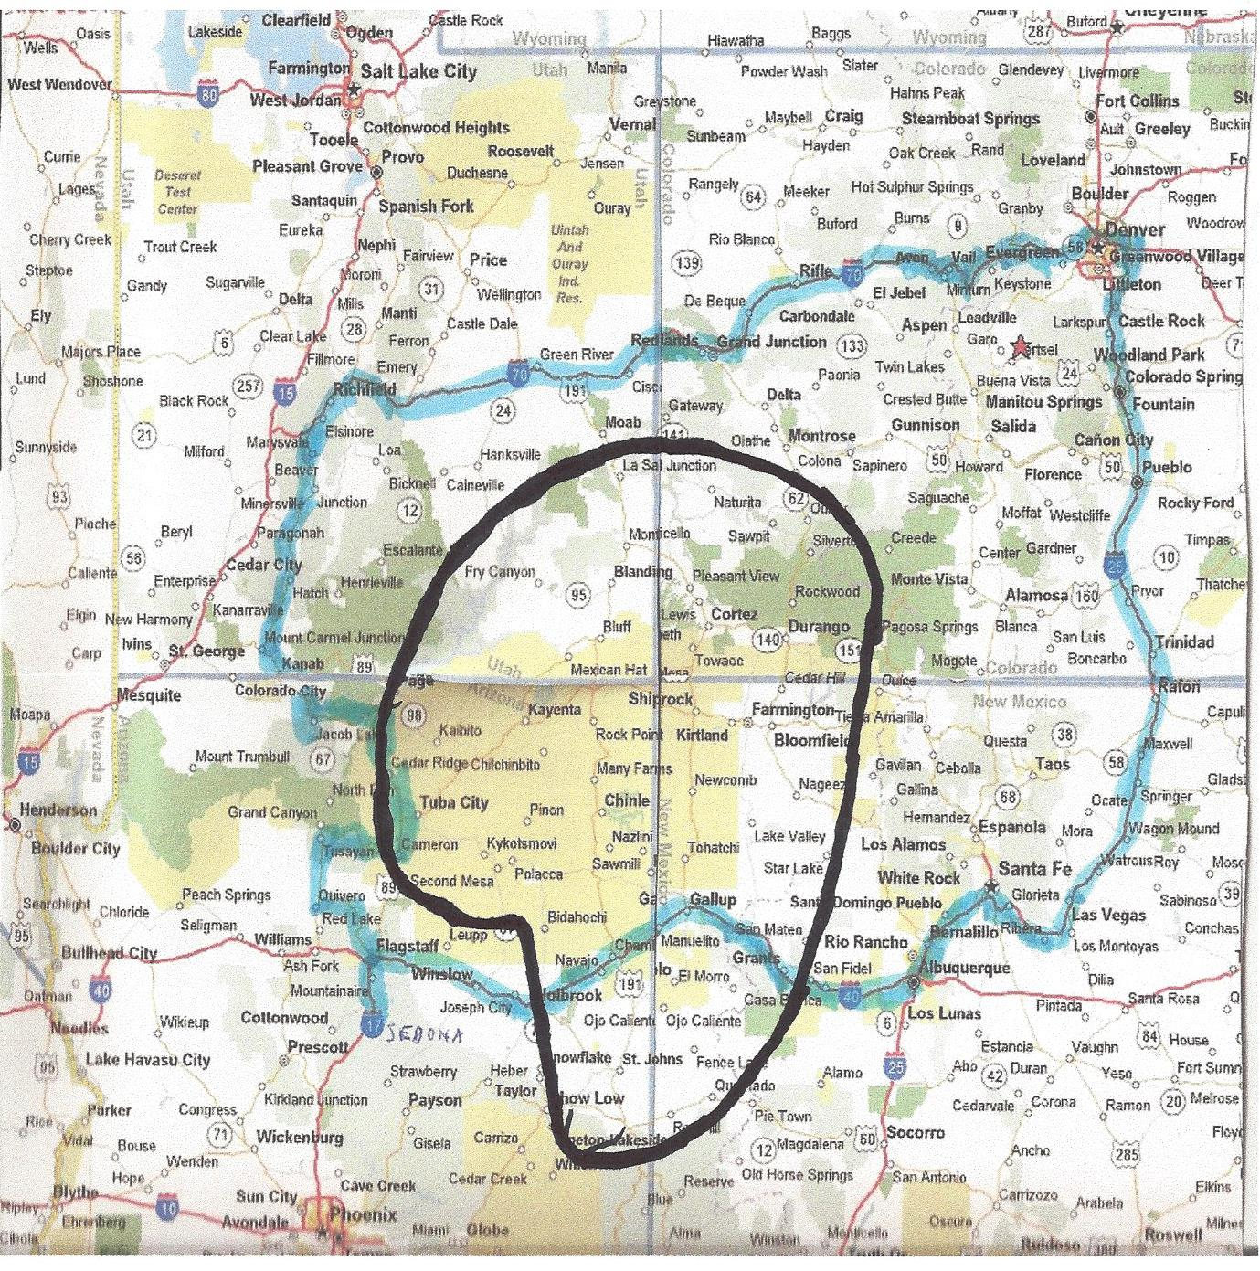

Boundary Line for Hosting a TSFA Convention/Training
TRI-STATE FIREMEN’S ASSOCIATION
2022 CURRENT MEMBERSHIP LIST

Bluewater Village Vol. Fire Dept
P.O. Box 7
Bluewater, NM 87005
Chief: Preston Neff
Ph# (505) 285-0568
Ph# (505) 240-5180

Dolores Fire Protection District
P. O. Box 599
Dolores, CO 81323
Chief: Mike Zion
Ph# (970) 882-4096

El Segundo Coal Company –ERT
P. O. Box 757
Grants, NM 87020
Chief: Marty Martinez
Ph# (505) 240-5180
Ph# (505)285-3048 Cotton

Fort Lewis Mesa Fire Department
164 County Road 130
Hespurus, CO 81326
Chief: John Lee
Email: chief@FLMfire.org
Ph# (970) 588-3400

Gallup Fire Department
1800 South Second Street
Gallup, NM 87301
Chief: Andres Campos
Email: acompas@gmail.com
Ph# (505) 722-4195

Grants Fire & Rescue
P. O. Box 879
Grants, NM 87020
Chief: Robert C. Hays
Email: firechief@grantsnm.gov
Ph# (505) 876-2245
Ph# (505) 240-1474

Lee Ranch Coal Company/ERT
P. O. Box 757
Grants, NM 87020
Chief: Cotton Jarrell
Ph# (505) 285-3048
Ph# (505) 240-5180

Lewis-Arriola Fire Department
PO Box 10
Lewis, CO 81327
Chief: George Deavers
Ph# (970) 882-7718
Ph# (970) 749-1771

Life Member Association
P. O. Box 2803
Milan, NM 87021
President: Kevin Starks
Ph# (970) 424-4360
Ph# (505) 285-9841 Carol Jarrell (d)
Ph# (505) 290-7341 Carol Jarrell (n)

Mancos Fire Protection District
P. O. Box 145
Mancos, CO 81328
Chief: Tony Aspromonte
Ph# (970) 533-7400
Home# (970) 389-7388

Milan Vol. Fire Department
P. O. Box 2867
Milan, NM 87021
Chief: Daniel Urioste
Email: milanfiredept@villageofmilan.com
Ph# (505) 287-7366
Ph# (505) 290-0549

Nucla Naturita Fire Department
P.O. Box 7409
Nucla, CO 81424
Chief: Bryan Keeton
Ph# (970) 864-7331

Pleasant View Fire Department
PO Box 291
Pleasant View, CO 81331
Chief: Angela Rohwer
Email: 500@pv-fire.com
Ph# (970) 739-6060
Ph# (970) 562-4375

Rico Fire Department
P.O. Box 39
Rico, CO 81332
Chief: Todd Jones
Email: rico_vfd@yahoo.com
Ph# (970) 967-2222
Ph# (970) 739-8481

San Mateo Vol. Fire Department
90517 San Mateo
San Mateo, NM 87020
Chief: Charles Ortega
Ph# (505) 249-4242

San Rafael Vol. Fire Department
P. O. Box 70
San Rafael, NM 87051
Chief: Dyvin Marez
Email: dmarezsrvfd@gmail.com
Ph# (505) 290-4491

TRI-STATE FIREMEN’S ASSOCIATION
2022 ARREAR MEMBERS

Bloomfield Fire Department
911 N. First Street
Bloomfield, NM 87413
Chief:
Ph# (505) 632-6363

Cortez Fire Rescue
31 N. Washington
Cortez, CO 81321
Chief: Jay Balfour
Ph# (970) 565-3157
Ph# (970) 570-5177

Mountainair Vol. Fire Department
P.O. Box 115
Mountainair, NM 87036
Chief: Wayne Jones
Ph# (505) 359-1344 (Betty Nelson)

Ute Mountain Fire & Rescue
P. O. Box 169
Towaoc, CO 81334
Chief: John Trocheck
Ph# (970) 564-5441
Email: JTrocheck@utemountain.org

White Cliffs Vol. Fire Dept.
P. O. Box 599
Gallup, NM 87301
Chief:
Ph# (505)
Ph# (505)
Board of Directors
2022-2023

Chairman of the Board:
Board Member –Colorado
Tony Aspromonte
P. O. Box 102
Mancos, CO 81328
Ph# (970) 533-7922
Ph# (970) 389-7388
E-Mail: TAspromonte@ElkGA.com

Board Member – Colorado
Lloyd Church
PO Box 101
Naturita, CO 81422
Ph# (970) 428-2871 (c)
E-mail:

Board Member – Colorado
Dyrl Graf
12130 CR 26
Cortez, CO 81321
Ph# (970) 564-9230 (h)
Ph# (970) 749-7918 (c)
E-mail: grafdiesel1@yahoo.com

Board Member – New Mexico
Bob Stalcup Jr.
P. O. Box 971
Bloomfield, NM 87413
Ph# (505) 320-5750 cell
E-mail: bnsfbob@sisna.com

Secretary/Treasurer
Board Member – New Mexico
Cindy A. Hays
519 Valencia Drive
Grants, NM 87020
Ph# (505)-240-2545 (cell)
E-mail: haysengraver@hotmail.com

Board Member – New Mexico
Ruben Aranda
664 East High Street
Grants, NM 87020
Ph# (505) 285-4163
E-mail: wiifmsafety@gmail.com

President – 2022 Host
Dyvin Marez
PO Box 324
San Rafael, NM 87051
Ph# (505) 290-4491
E-Mail: dmarezsrvfd@gmail.com

Past Host – 2022
Mike Zion
Po Box 507
Dolores, CO 81323
Ph# (970) 759-3541
E-Mail: mikezion73@hotmail.com

Adopted by the Tri-State Firemen’s Association Organization on this 30th day of September 2022.

SIGNED Tony Aspromonte DATE 9/30/2022
Board of Directors, Chairman

SIGNED Cindy A. Hays DATE 9/30/2022
Board of Directors, Secretary/Treasurer

